IF YOU GOT A LENGTH OF **20**, THEN SOLVE:



If $\overline{BC}∥\overline{B'C'}$ and $\overline{AC}=4, \overline{CC'}=2$ and $\overline{BC}=7$, find $\overline{B'C'}$.

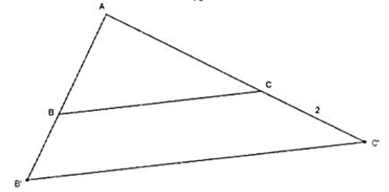

IF YOU GOT A LENGTH OF **10.5**, THEN SOLVE:

If $∡CFE≅∡CAB$, find $\overline{AB}$.

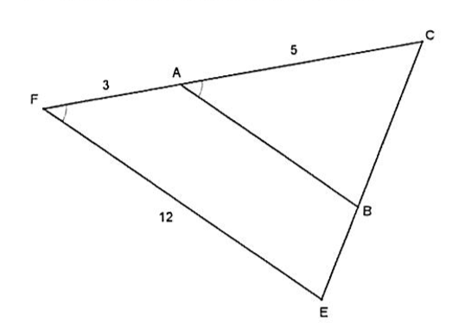

IF YOU GOT A LENGTH OF **7.5**, THEN SOLVE:

In $∆ABD$, $\overline{DE}⊥\overline{EC}$ and $\overline{AD}⊥\overline{AB}$, find the measure of $\overline{AE}$.

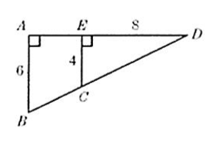

IF YOU GOT A LENGTH OF **4**, THEN SOLVE:

Given $∆ACB$ with $\overline{MN}∥\overline{AB}$, find the length of $\overline{MN}$.

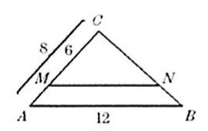

IF YOU GOT A LENGTH OF **9** THEN SOLVE:

A stick 2 meters long is placed vertically at point B. The top of the stick is in line with the top of a tree as seen from point A, which is 3 m from the stick and 30 m from the tree. How tall is the tree?

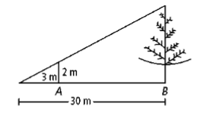

**SCAVENGER HUNT WORKSPACE:**

* Use the space below to complete the 5 problems in the scavenger hunt. (You may need to re-draw diagrams)
* Answer the problem on each worksheet and find the answer on another worksheet in the room. (IF YOU DO NOT SEE YOUR ANSWER, CHECK YOUR WORK AGAIN!)
* Then answer that problem and repeat the process.
* If you end up in the same place you started, you have successfully completed the scavenger hunt!

|  |  |
| --- | --- |
|  |  |
|  |  |
|  |  |
|  |  |